**Modern Thick Wall Shelf with lights**

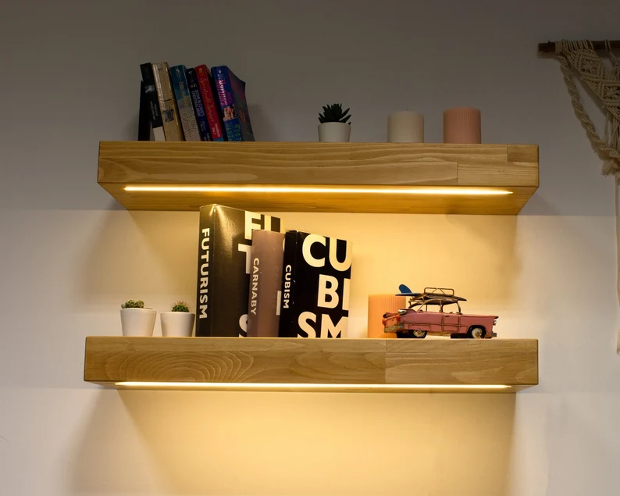 A Modern Thick Wall Shelf with Lights is a functional and stylish piece of furniture that not only provides storage and display space but also adds an atmospheric touch to any room. Crafted from sturdy materials like wood or metal, these shelves feature a thick, solid design that exudes strength and sophistication. The integrated lighting, often LED, highlights the items displayed on the shelf, creating a warm, ambient glow that enhances the room's mood. Perfect for living rooms, bedrooms, or offices, these shelves are ideal for showcasing books, plants, or artwork while simultaneously brightening up the space in a modern and sleek way.